Computer Language Coding Concepts

Continue in a Diagram
The concept of Continue was already covered by the article Continue. This article only explains its expression in a diagram.

As explained in the article Continue, the Continue command means no more than to exit the procedure that is looped.

So in the expression in a diagram, you see a loop, that has the command to loop associated to it. A continue statement looks the same as to exit a command:

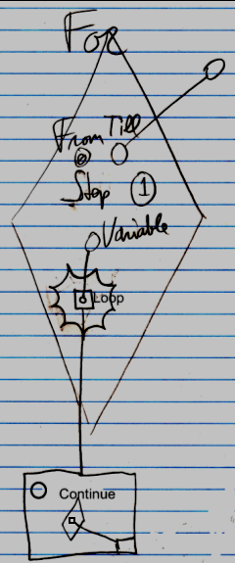

See also: Continue, Exit Command in a Diagram

Author & Copyright: Jan-Joost van Zon Date: June 11, 2008 – June 11, 2008 Location: Oosterhout, The Netherlands Status: Finished

